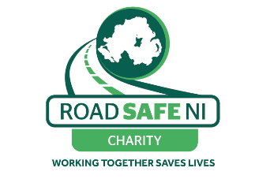

Northern Ireland Road Safety Awards 2023

Nomination form
Please select the category below you are nominating the project, person or organisation for and mark the appropriate box with an ‘X’.

1 | Primary School  A primary school child, children, school or teacher can be nominated for their involvement in any road safety initiative.
2 | Secondary School  A secondary school child, children, school or teacher can be nominated for their involvement in any road safety initiative.
3 | Lollipop Person  A lollipop person that goes beyond the call of duty to ensure children’s safety on the roads.
4 | Driving Instructor (ADI)  A driving instructor can be nominated for their involvement in a road safety initiative.
5 | Emergency Services Person  An Emergency Services person can be nominated for going above the call of duty or for their involvement in any road safety initiative.
6 | Voluntary Sector  A person or organization within the voluntary sector can be nominated for their involvement in any road safety initiative.
7 | LGV / PCV  A driver or company who through their actions, promote the road safety message can be nominated.
8 | Business Sector  This category is open to any business that promotes road safety within or outside of their company.
9 | Public Sector  Open to any public sector employee or organisation that go above beyond to ensure roads are safer.
10 | Young Driver  This category is open to young drivers that have demonstrated a high level of respect and positive attitudes towards other road users
11 | Open Category  This is a special category introduced last year aimed at any person or organisation that is making or has made a contribution to road safety that does not fit into other categories.
12 | Lifetime Achievement  This category is open to any individual who have selflessly contributed to road safety over a long period of time.
13 | Two Wheels  This category is open to cyclists, motorcyclists or related clubs or groups
14 | Transport Manager  Open to any haulage or transport company managers that go above and beyond to ensure road safety.

Your details (person making the nomination). You can self-nominate.
Name: _________________________________________
Contact number: _________________________________________
Email: _________________________________________

Details for the Nominated Project/Person or Organisation (We will only contact them if they are selected as a category winner or are highly commended)
Project/Person/Organisation Name: ___ __________________________________
Project/Person/Organisations Contact Name: __________________________________
Address: _________________________________________
_________________________________________
Contact number: __________________________________________
E-Mail Address: __________________________________________
Project details: Please outline why you have nominated this project/person or organisation for the award including the road safety issue they were addressing.

(Max 400 words)

Describe the results of the road safety activity undertaken by the project/person or organisation? What has been achieved? (Max 400 words)

Nomination forms can be returned via email to info@roadsafeni.org or roadsafenicharity@gmail.com before 5pm on Friday 27th October 2023. If you prefer to post, please return to Davy Jackson, Road Safe NI, 48 Copperthorpe, Drumahoe, Co. Londonderry, BT47 3LT

